# Software Requirement and Design Specifications

**Event Management**

***Version: 1.0***

|  |  |
| --- | --- |
| Course Code | CS 3004 |
| Instructor | Miss Nida Munawar |
| Project Team | 21K-3272 Huzaifa Quaid  21K-3232 Ahmed Saif  21K-3333 Saleh Shamoon |
| Submission Date | 3/12/23 |

Table of Contents

1. Introduction 4
   1. Purpose of Document 4
   2. Intended Audience 4
2. Overall System Description 5
   1. Project Background 5
   2. Project Scope 5
   3. Not In Scope 5
   4. Project Objectives 5
   5. Stakeholders 5
   6. Operating Environment 5
   7. System Constraints 5
   8. Assumptions & Dependencies 6
3. External Interface Requirements 7
   1. Hardware Interfaces 7
   2. Software Interfaces 7
   3. Communications Interfaces 7
4. Functional Requirements 8
   1. Functional Hierarchy 8
   2. Use Cases 9
      1. [Title of use case] 10
5. Non-functional Requirements 11
   1. Performance Requirements 11
   2. Safety Requirements 11
   3. Security Requirements 11
   4. User Documentation 11

SDS 12

1. SYSTEM ARCHITECTURE 13
   1. System Level Architecture 13
   2. Software Architecture 14
2. DESIGN STRATEGY 15
3. DETAILED SYSTEM DESIGN 16
   1. Database Design 26
4. Application Design 25
5. References 28
6. Appendices 29

## Introduction

##### Purpose of Document

To outline the requirements for the development of the Event Management system.

##### Intended Audience

Students, Event representative and university admin

* 1. **Definition of Terms, Acronyms and Abbreviations**

This section should provide the definitions of all terms, acronyms, and abbreviations required to interpret the terms used in the document properly.

|  |  |
| --- | --- |
| **Term** | **Description** |
| ASP | Active Server Pages |
| DD | Design Specification |
| EM | Event Manager |
|  |  |
|  |  |
|  |  |
|  |  |
|  |  |

##### Document Convention

Arial Font with size 10 or 12

## Overall System Description

##### Project Background

Extracurricular events are a crucial part of a university experience. Currently, all the event related information is broadcasted through Gmail which can result in unnecessary clutter, making it hard to later search for specific info. The website will keep up to date track of all event important dates and allow for easy registration. It’s a matter of convenience

##### Project Scope

The system will allow a student/user to view current and upcoming events along with their information. The student can then register for any of the events and see the record of all the events they were previously registered in. The system allows event representative to edit the information related to any events and see all the participants. The admin can view all the participants as well as remove or add more events.

##### Not In Scope

The system will not be handling any financial transactions such as ticket sales etc. No real time communication such as live chat is included, info will be shared primarily through event details.

##### Project Objectives

The system streamlines university event management, facilitating user registration and empowering event representatives. Administrators gain oversight for strategic decision-making. A user-friendly interface and robust data security enhance positive experiences. Scalability, accessibility, and comprehensive documentation support growth and usability.

##### Stakeholders

Students, Faculty and staff, Event representatives, Admin and System Developers.

##### Operating Environment

The system operates in a web-based environment. The hardware requirements include standard computing devices such as desktops, laptops, tablets, and smartphones with modern web browsers (Google Chrome, Mozilla Firefox, Safari, or Microsoft Edge) for user accessibility. The system is designed to function on both Windows and macOS operating systems. Internet connectivity is required for accessing the web application and receiving real-time updates.

##### System Constraints

**Software Constraints:**

The system is bound by the compatibility and limitations of the chosen software technologies. Dependencies on third-party libraries and frameworks may introduce constraints regarding version compatibility and updates.

**Hardware Constraints:**

The system relies on standard computing devices, and constraints may arise concerning the processing power, memory, and storage capacity of these devices. Server infrastructure limitations could impact the system's scalability.

**Cultural Constraints:**

Cultural constraints include language considerations for user interfaces and communications.

**Legal Constraints:**

Adherence to data protection laws, privacy regulations, and intellectual property rights is essential. Legal constraints also encompass any university policies or regulations governing event management and data handling.

**Environmental Constraints:**

The environment in which the software is utilized may impact user experience. For instance, if used in noisy surroundings, the system should provide visual cues rather than relying on sound events for important notifications.

**User Constraints:**

User constraints involve considerations based on the target audience. The system should be designed with an intuitive user interface, especially if the primary users are students or individuals less familiar with complex interfaces.

**Off-the-Shelf Components:**

The project may leverage off-the-shelf components (e.g., databases, authentication systems), and constraints associated with these components, such as licensing limitations or feature restrictions, must be considered.

##### Assumptions & Dependencies

Assumptions made during the project include the availability of consistent internet connectivity for end-users and the proper functioning of web browsers. It is assumed that the university's IT infrastructure can support the hosting requirements of the system. Dependencies include the timely availability of user authentication services provided by the university's IT department. Additionally, assuming periodic updates to external libraries and frameworks to maintain system security and performance. External dependencies include the continued support and compatibility of web browsers and server hosting services.

## External Interface Requirements

**3.1. Hardware Interfaces**

The system interfaces with various hardware components to ensure optimal functionality across devices. Supported devices include standard computing equipment such as desktop computers, laptops, tablets, and smartphones. The system adapts its user interface to cater to different screen sizes and resolutions. Data interactions involve user input through devices and output through display interfaces. Control interactions include keyboard input, and mouse interactions.

**3.2. Software Interfaces**

The system integrates with external software components to enhance its capabilities. It interfaces with the university's authentication system for user management, ensuring secure access control. Additionally, integration with external databases allows for the retrieval and storage of relevant event and user information. The system also communicates with operating systems, web browsers. Data exchanges include user details, event information facilitating seamless interactions between the software components.

**3.3. Communications Interfaces**

The system relies on various communication functions to ensure effective operation. Web browsers serve as the primary interface for user interactions, supporting standard web communication protocols. Network communications adhere to established standards, facilitating data transfer rates optimized for efficient system performance. Security measures, including encryption, are implemented to safeguard sensitive data during communication, enhancing overall system integrity and user privacy.

## Functional Requirements

##### Functional Hierarchy

1. User Management Module:

1.1 User Registration

1.2 User Authentication

1.3 User Profile Management

2. Event Management Module:

2.1 Event Creation

2.2 Event Editing

2.3 Event Deletion

2.4 Event Visibility Settings

3. Participant Registration Module:

3.1 Registration for Events

3.2 Cancellation Process

4. Event Representative Module:

4.1 Representative Authentication

4.2 Event Update and Modification

4.3 Participant Tracking

5. Administrative Module:

5.1 Administrative Authentication

5.2 Adding and Removing Events

##### Use Cases

#### Event Management

|  |  |
| --- | --- |
| **Use Case Description** | |
| **Use Case name:** | **Managing Events based on roles** |
| **Use Case Description: This use case describes the behavior of the university event management website in adapting its interface based on the roles of the logged-in user.** | |
| **Primary actor: User** | **Other actors: Event representative, Admin** |
| **Stakeholders: Users, Event representatives and Admins** |  |
| **Relationships**   * **Includes: Authentication and user-specific interface adaptation based on roles.** * **Extends: None** | |
| **Pre-conditions:**  **- The website is accessible and functional.**  **- User, Event Representative, and Admin credentials are registered in the system.** | |
| **Flow of Events:**  **1. Actor logs into the EM website.**  **2. System authenticates user credentials.**  **3. Based on the user's role (User, Event Representative, or Admin), the system adapts the interface accordingly:**  **- For a User:**  **- Presents a basic interface with access to homepage, about section, events page, current events page, upcoming events page, and register for events page.**  **- For an Event Representative:**  **- Presents an interface with additional functionalities to monitor registrations and update event information.**  **- For an Admin:**  **- Presents an interface with administrative controls to add/remove events and manage registrations.**  **4. User interacts with the interface based on their role.** | |
| **Alternative and exceptional flows:**  **- 4.1 Actor's login credentials are invalid.**  **- The system prompts the user to re-enter valid credentials.**  **- On repeated failure, denies access to the system.** | |
| **Post-conditions:**  **- User interacts with the interface according to their role-based permissions.**  **- System maintains the security and integrity of user-specific functionalities based on roles.** | |

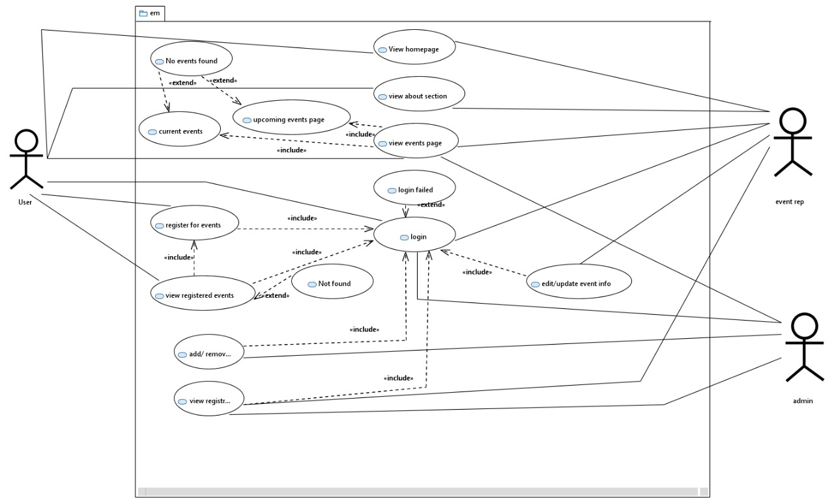

## Non-functional Requirements

5.1. Performance Requirements:

The system is expected to respond promptly. It aims for concurrent usage with a minimum of 300 users during peak times and accommodating 2,000 registered users and 50 events concurrently.

5.2. Safety Requirements:

To prioritize user safety, the system implements regular data backups, robust access control mechanisms.

5.3. Security Requirements:

Security measures include strong user authentication, regular security audits, and compliance with privacy policies and regulations.

5.4. User Documentation:

Comprehensive user documentation, including manuals will be provided to facilitate user understanding and proficiency.

# SDS

## System Architecture

### System Level Architecture

### Deployment Diagram

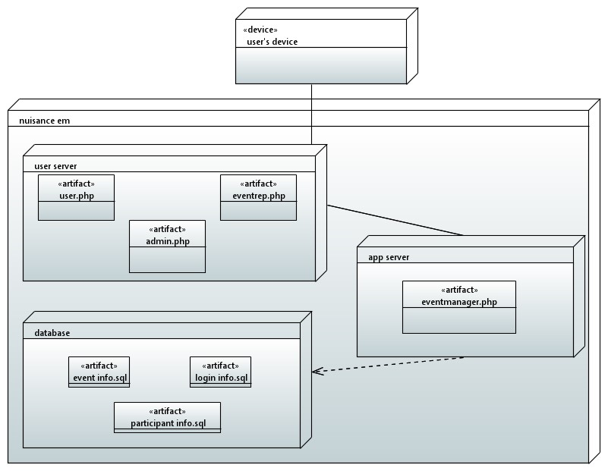

**Collaboration Diagram**

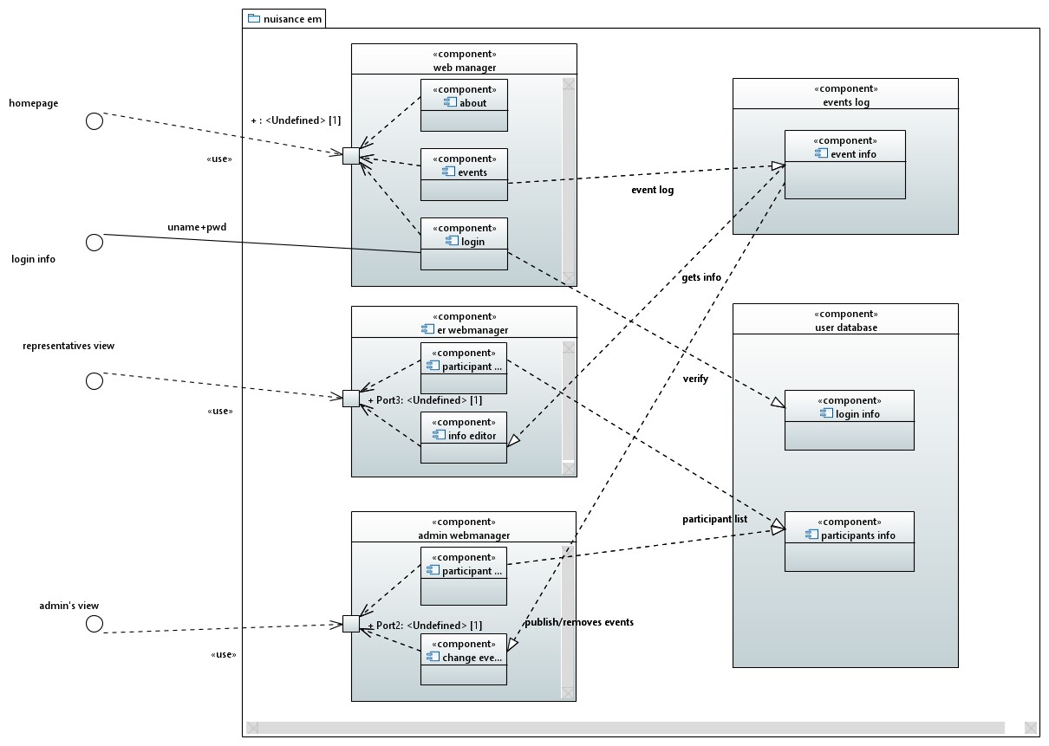

### Software Architecture

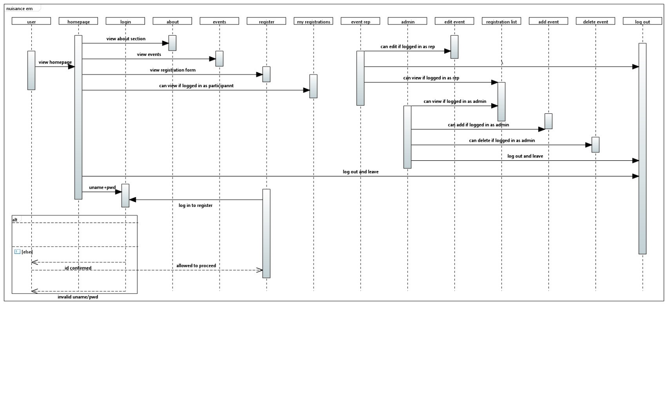

## Design Strategy

The design strategy for the Event Manager system is centered around flexibility, scalability, and user-centricity, addressing key considerations in various aspects:

- **Future System Extension or Enhancement:**

- The architecture is designed to accommodate future system extensions or enhancements seamlessly. Modular components and adherence to industry-standard coding practices enable efficient updates and additions, ensuring the system's adaptability to evolving requirements.

- **System Reuse:**

- Reusable components are emphasized in the design to promote efficiency and reduce redundancy. A modular structure allows for the reuse of key functionalities across different system modules, enhancing maintainability and scalability.

- **User Interface Paradigms:**

- The user interface prioritizes intuitive design and responsiveness. A combination of graphical controls and textual information ensures accessibility and usability for a diverse user base, aligning with the project's user-centric design principles.

- **Data Management (Storage, Distribution, Persistence):**

- Data management revolves around a relational database model, ensuring efficient storage, retrieval, and maintenance of event and user information. Distribution strategies consider load balancing for optimal performance during peak usage.

- **Concurrency and Synchronization:**

- Concurrency and synchronization are addressed through careful design of database transactions and communication protocols. Concurrent user interactions, such as event registrations, are managed systematically to prevent data inconsistencies and ensure a seamless user experience.

This design strategy seeks to balance the need for system extensibility and reuse with the demand for a user-friendly and performant system. By prioritizing these considerations, the "Event Manager" system aims to provide a solid foundation for current functionality while allowing for future enhancements and scalability.

## Detailed System Design

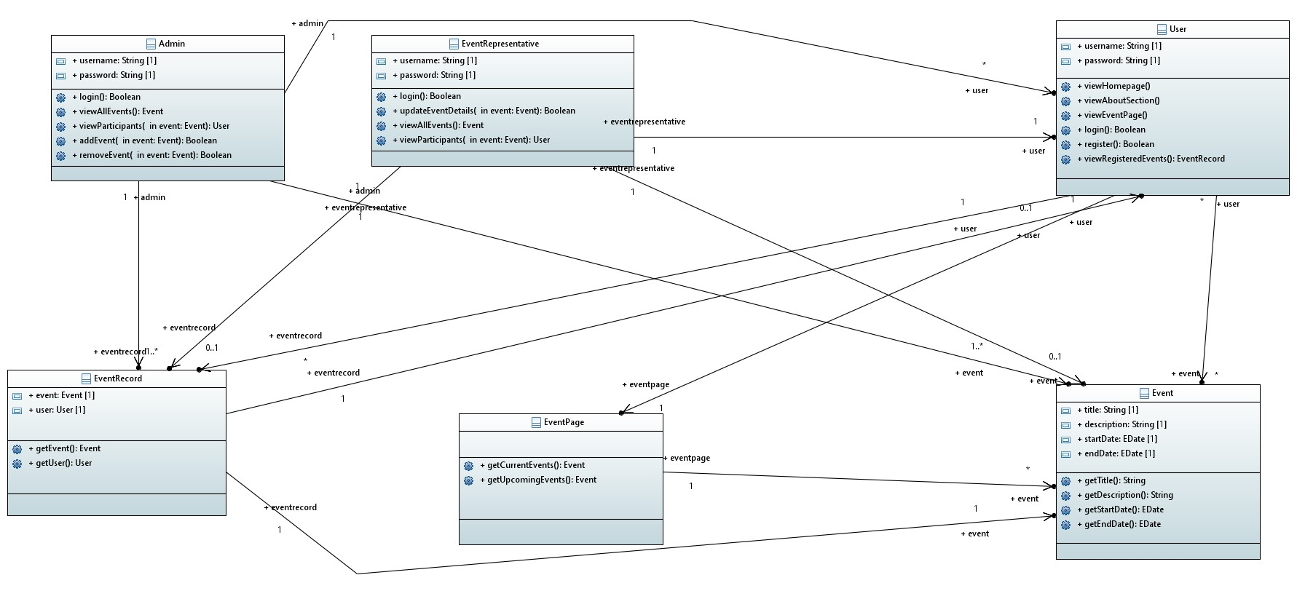

1. **User Class:**

- Attributes:

- username: String - Represents the username of the user.

- password: String - Represents the password of the user.

- Methods:

- viewHomepage(): Displays the homepage for the user.

- viewAboutSection(): Displays the about section for the user.

- viewEventPage(): Displays the event page for the user.

- login(): Authenticates the user.

- register(): Registers the user for the system.

- viewRegisteredEvents(): Returns a list of events the user is registered in.

2. **Event Class:**

- Attributes:

- title: String - Represents the title of the event.

- description: String - Represents the description of the event.

- startDate: Date - Represents the start date of the event.

- endDate: Date - Represents the end date of the event.

- Methods:

- getTitle(): Returns the title of the event.

- getDescription(): Returns the description of the event.

- getStartDate(): Returns the start date of the event.

- getEndDate(): Returns the end date of the event.

3. **EventPage Class:**

- Methods:

- getCurrentEvents(): Returns a list of current events.

- getUpcomingEvents(): Returns a list of upcoming events.

4. **EventRecord Class:**

- Attributes:

- event: Event - Represents the associated event.

- user: User - Represents the associated user.

- Methods:

- getEvent(): Returns the associated event.

- getUser(): Returns the associated user.

5. **EventRepresentative Class:**

- Attributes:

- username: String - Represents the username of the event representative.

- password: String - Represents the password of the event representative.

- Methods:

- login(): Authenticates the event representative.

- updateEventDetails(event: Event): Updates details of a specified event.

6. **Admin Class:**

- Attributes:

- username: String - Represents the username of the admin.

- password: String - Represents the password of the admin.

- Methods:

- login(): Authenticates the admin.

- viewAllEvents(): Returns a list of all events.

- viewParticipants(event: Event): Returns a list of participants for a specified event.

- addEvent(event: Event): Adds a new event to the system.

- removeEvent(event: Event): Removes a specified event from the system.

**Relationships:**

1. User and EventRecord:

- A User can be associated with multiple EventRecords.

2. User and EventPage:

- A User is associated with a single EventPage.

3. User and Event:

- A User can be associated with multiple Events.

4. EventPage and Event:

- An EventPage is associated with multiple Events.

5. EventRecord and Event:

- An EventRecord is associated with a single Event.

6. EventRecord and User:

- An EventRecord is associated with a single User.

7. EventRepresentative and Event:

- An EventRepresentative can be associated with multiple Events.

8. EventRepresentative and User:

- An EventRepresentative is associated with a single User.

9. Admin and Event:

- An Admin can be associated with multiple Events.

10. Admin and User:

- An Admin can be associated with multiple Users.

11. Admin and EventRecord:

- An Admin can be associated with multiple EventRecords.

**Gui Screenshots:**



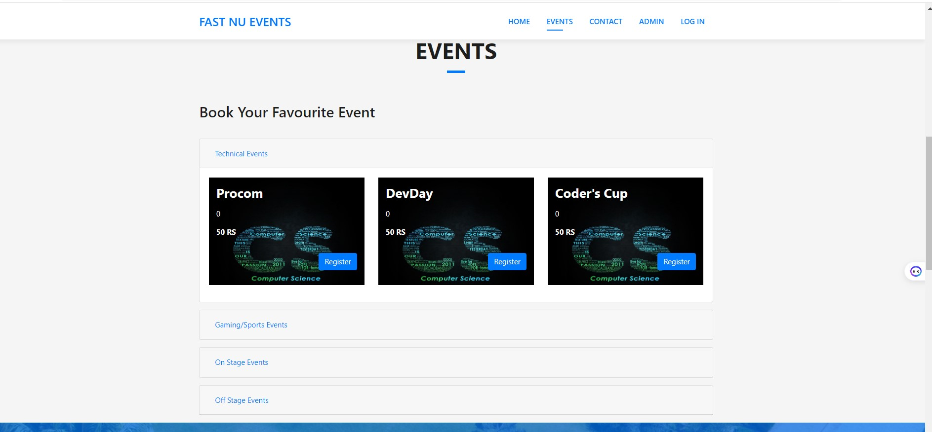

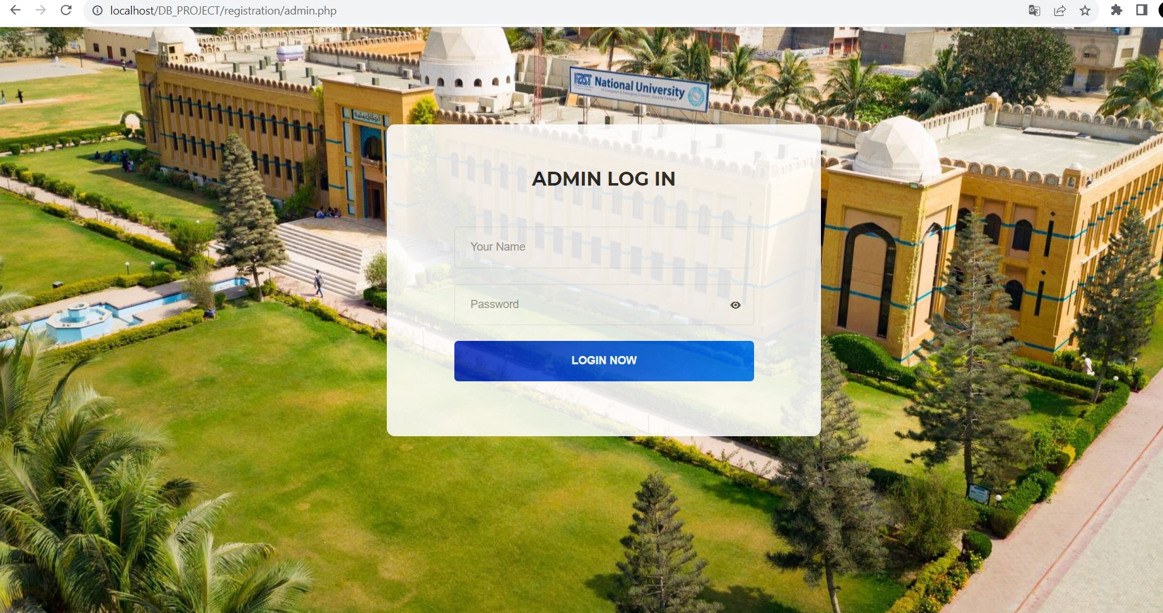

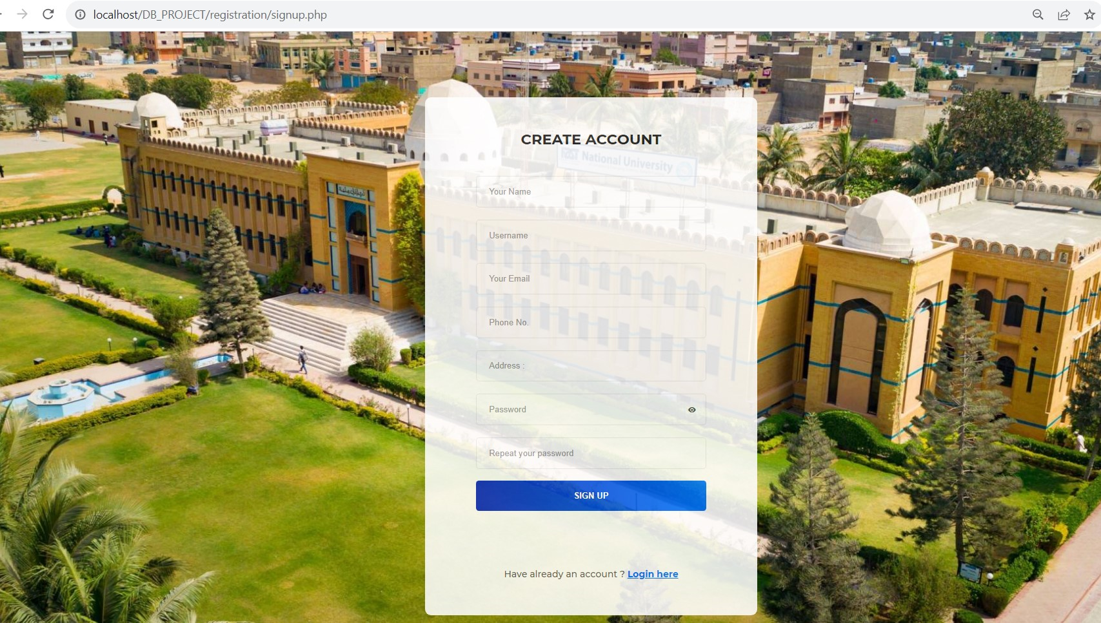

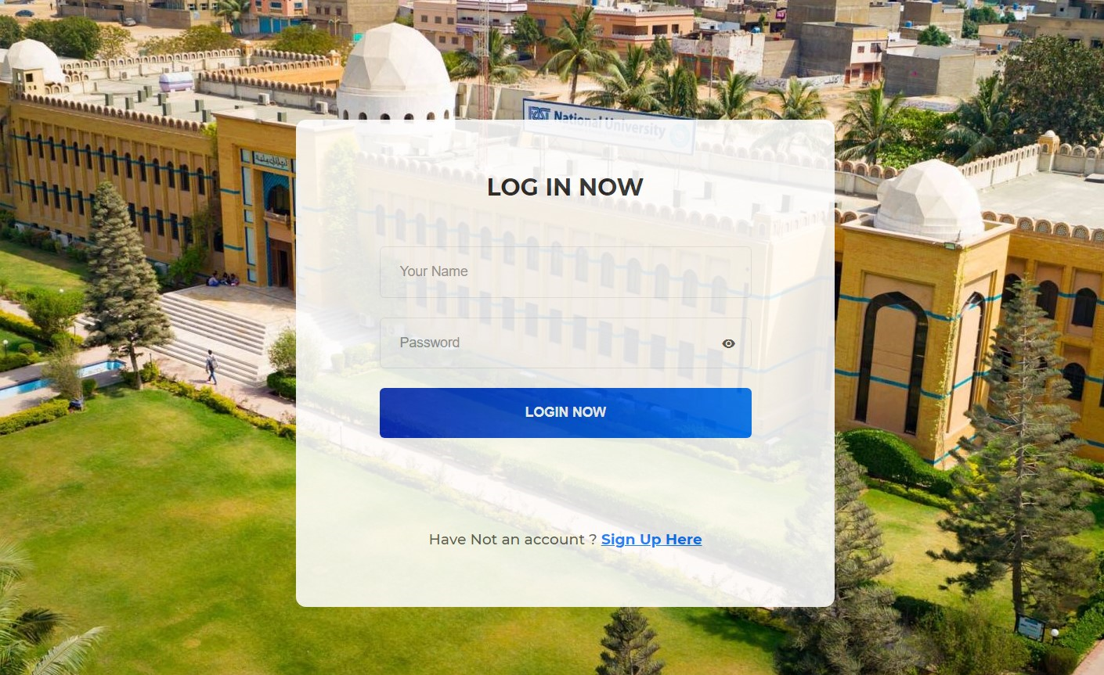

### Database Design

#### ER Diagram

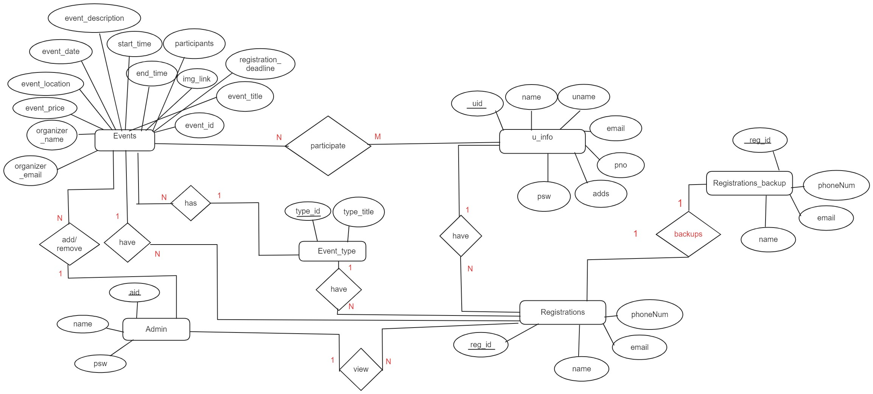

#### Data Dictionary

|  |  |  |  |  |  |  |  |
| --- | --- | --- | --- | --- | --- | --- | --- |
| **< Data 1>** | | | | | | | |
| **Name** | | User | | | | | |
| **Alias** | | NA | | | | | |
| **Where-used/how- used** | | Used in the User Management Module for user registration, authentication, and profile management.  Utilized in the Participant Registration Module for event registrations and cancellation processes. | | | | | |
| **Content description** | | Stores information about system users, facilitating registration, authentication, and event participation. | | | | | |
|  | | | | | | | |
| **Column Name** | **Description** | | **Type** | **Length** | **Null able** | **Default Value** | **Key Type** |
| uid | Stores user ID | | varchar | 20 | No | (Null) | PK |
| name | Name of user | | varchar | 50 | No | (Null) |  |
| uname | Username for login | | varchar | 50 | No | (Null) |  |
| email | Email of user | | varchar | 100 | No | (Null) |  |
| pno | Phone num | | number | 11 | Yes | (Null) |  |
| address | Residential address | | varchar | 100 | Yes | (Null) |  |
| password | Pass for login | | varchar | 50 | No | (Null) |  |
|  |  | |  |  |  |  |  |

|  |  |  |  |  |  |  |  |
| --- | --- | --- | --- | --- | --- | --- | --- |
| **< Data 2>** | | | | | | | |
| **Name** | | Admin | | | | | |
| **Alias** | | NA | | | | | |
| **Where-used/how- used** | | Employed in the Administrative Module for authentication and management of events (adding, removing). | | | | | |
| **Content description** | | Holds data related to administrators, enabling authentication and control over event management functions. | | | | | |
|  | | | | | | | |
| **Column Name** | **Description** | | **Type** | **Length** | **Null able** | **Default Value** | **Key Type** |
| aid | Admin ID | | varchar | 10 | No | (Null) | PK |
| name | Admin name | | varchar | 30 | No | (Null) |  |
| password | Admin password | | varchar | 50 | No | (Null) |  |

|  |  |  |  |  |  |  |  |
| --- | --- | --- | --- | --- | --- | --- | --- |
| **< Data 3>** | | | | | | | |
| **Name** | | Event | | | | | |
| **Alias** | | NA | | | | | |
| **Where-used/how- used** | | Integral to the Event Management Module for event creation, editing, and deletion. | | | | | |
| **Content description** | | Stores details about university events, facilitating event creation, management, and participant interaction. | | | | | |
|  | | | | | | | |
| **Column Name** | **Description** | | **Type** | **Length** | **Null able** | **Default Value** | **Key Type** |
| Event_id | Event ID | | Varchar | 10 | No | (null) | PK |
| Event_title | Event Title | | Varchar | 50 | No | (null) |  |
| Participants | People taking part | | Int | 10 | Yes | 0 |  |
| Price | Price of registration | | Number | 10 | No | (null) |  |
| Img_link | Event thumbnail | | Link | - | No | (null) |  |
| Type_id | category | | Varchar | 10 | no | (null) | FK |

|  |  |  |  |  |  |  |  |
| --- | --- | --- | --- | --- | --- | --- | --- |
| **< Data 4>** | | | | | | | |
| **Name** | | Event_type | | | | | |
| **Alias** | | NA | | | | | |
| **Where-used/how- used** | | Linked to the Event entity for categorizing events based on types. | | | | | |
| **Content description** | | Defines different types of events, aiding in event categorization | | | | | |
|  | | | | | | | |
| **Column Name** | **Description** | | **Type** | **Length** | **Null able** | **Default Value** | **Key Type** |
| Type_id | Event Type ID | | Varchar | 10 | No | (Null) | PK |
| Type_title | Event type title | | varchar | 50 | No | (Null) |  |
|  |  | |  |  |  |  |  |

|  |  |  |  |  |  |  |  |
| --- | --- | --- | --- | --- | --- | --- | --- |
| **< Data 5>** | | | | | | | |
| **Name** | | Registration | | | | | |
| **Alias** | | NA | | | | | |
| **Where-used/how- used** | | Part of the Participant Registration Module for tracking registrations and confirmations.  Linked to the Event and User entities for managing event participation. | | | | | |
| **Content description** | | Records information about user registrations for events, enabling effective event participation tracking. | | | | | |
|  | | | | | | | |
| **Column Name** | **Description** | | **Type** | **Length** | **Null able** | **Default Value** | **Key Type** |
| Reg_id | Registration ID | | Varchar | 10 | No | (Null) | PK |
| U_id | User ID registered | | Varchar | 10 | No | (Null) | FK |
| Name | Name of registered user | | Varchar | 50 | No | (Null) |  |
| Email | Email of registered user | | Varchar | 100 | No | (Null) |  |
| phoneNum | No. of registered user | | Number | 11 | Yes | (Null) |  |
| Type_id | Event id | | Varchar | 10 | No | (Null) | FK |
| Event_id | Event type id | | varchar | 10 | No | (Null) | FK |

### Application Design

#### Sequence Diagram

###### Sequence Diagram

###### 

The basic first few steps in the sequence diagram are the same for every user up until the login, the user can view the 3 basic pages provided i.e. homepage, about section and events. Once the user logs in as an individual participant, it redirects it to a different interface which allows the user to register and partake in events, allows the user to also view the events they have registered themselves in. In the event representative log in, the interface provides the rep with the option to edit or update information regarding the events present on the site. The rep can also view the list of participants and events they took part in. the admin login allows the admin to add or remove events from the website and also view the list of participants and the event they took part in. everyone is also provided with a log out option.

#### State Diagram

###### State Diagram

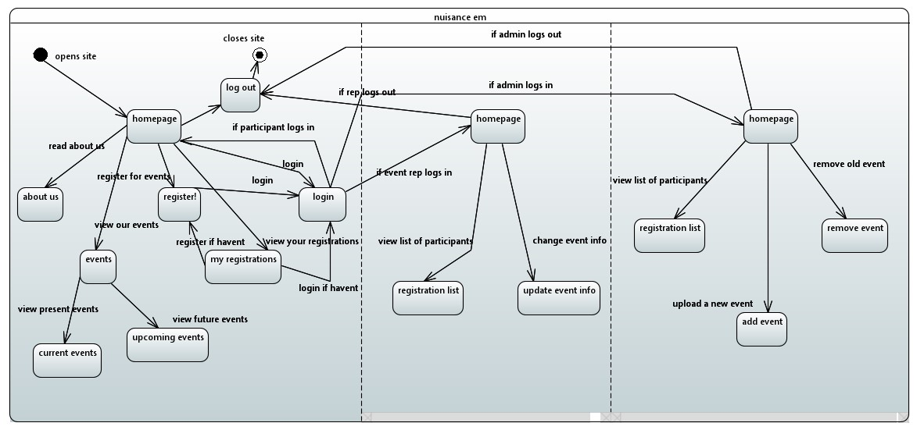

The basic first few steps in the state diagram are the same for every user up until the login, the user can view the 3 basic pages provided i.e., homepage, about section and events. Once the user logs in as an individual participant, it redirects it to a different interface which allows the user to register and partake in events, allows the user to also view the events they have registered themselves in. In the event representative log in, the interface provides the rep with the option to edit or update information regarding the events present on the site. The rep can also view the list of participants and events they took part in. the admin login allows the admin to add or remove events from the website and also view the list of participants and the event they took part in. everyone is also provided with a log out option.

#### Activity Diagram

###### Activity Diagram

###### 

The basic first few steps in the activity diagram are the same for every user up until the login, the user can view the 3 basic pages provided i.e., homepage, about section and events. Once the user logs in as an individual participant, it redirects it to a different interface which allows the user to register and partake in events, allows the user to also view the events they have registered themselves in. In the event representative log in, the interface provides the rep with the option to edit or update information regarding the events present on the site. The rep can also view the list of participants and events they took part in. the admin login allows the admin to add or remove events from the website and also view the list of participants and the event they took part in. everyone is also provided with a log out option.

## Reference

## Not applicable

## Appendices

Not applicable